DATA STRUCTURES AND ALGORITHMS LAB – 2 ASSIGNMENT

Student Details
- Name: Pratyush Deo Singh
- Registration Number: 25BCE5101
- Course / Branch: B. Tech CSE (CORE)
- Semester: 2nd
- Subject: Data Structures and Algorithms
- Faculty Name: Dr. Malini A

Program 1: Quick Sort
Aim
To write a C program to sort elements using Quick Sort technique.
Algorithm
- Read number of elements
- Read array elements
- Select a pivot element
- Partition the array
- Apply quick sort recursively

Program Code
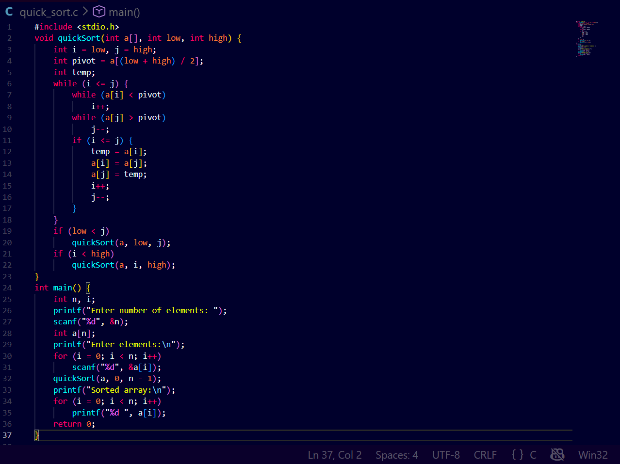Output
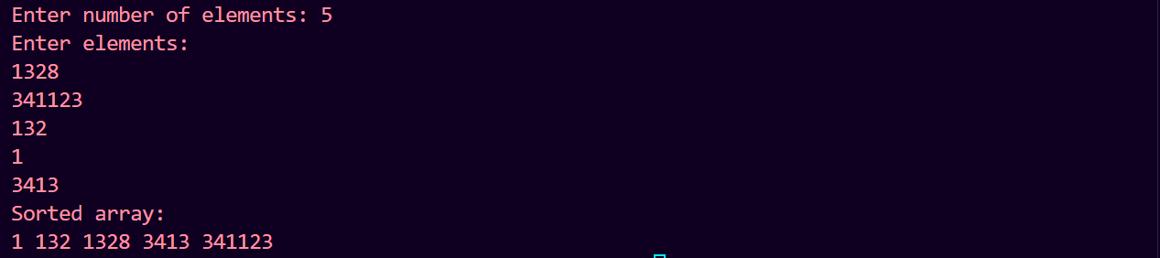

Program 2: Merge Sort

Aim
To write a C program to sort elements using Merge Sort technique.

Algorithm
- Read number of elements
- Divide array into subarrays
- Sort subarrays recursively
- Merge the sorted subarrays

Program Code
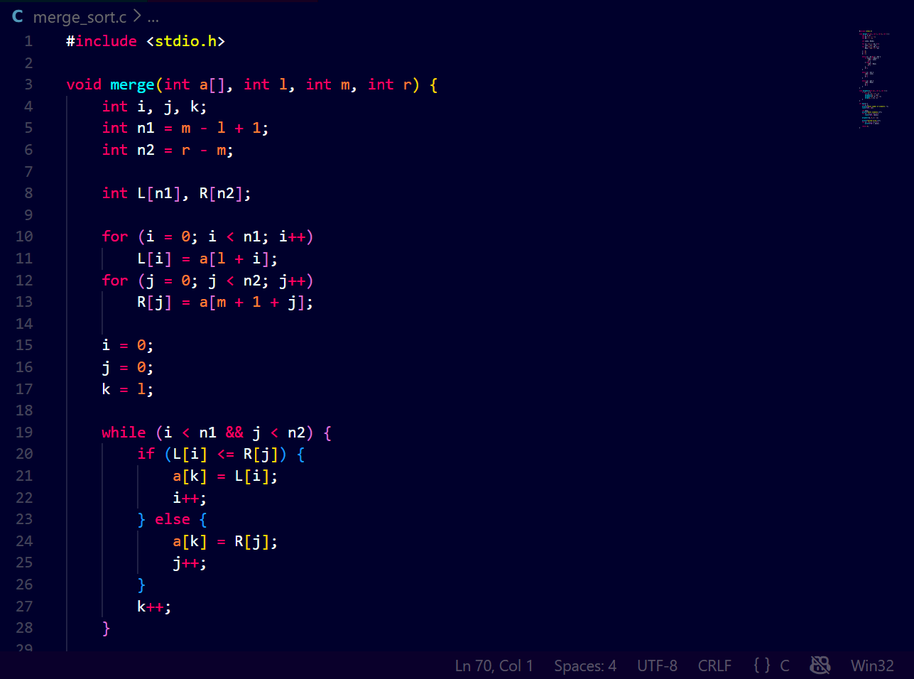
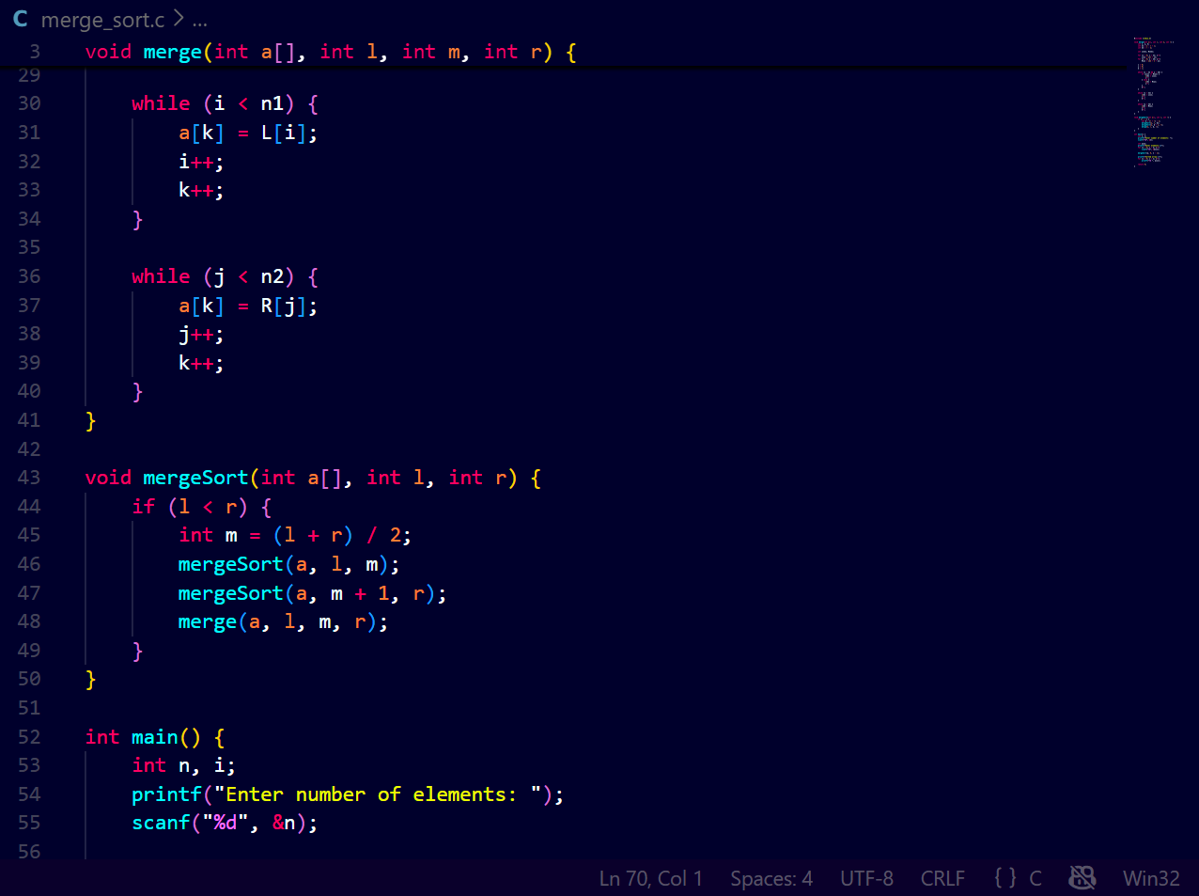
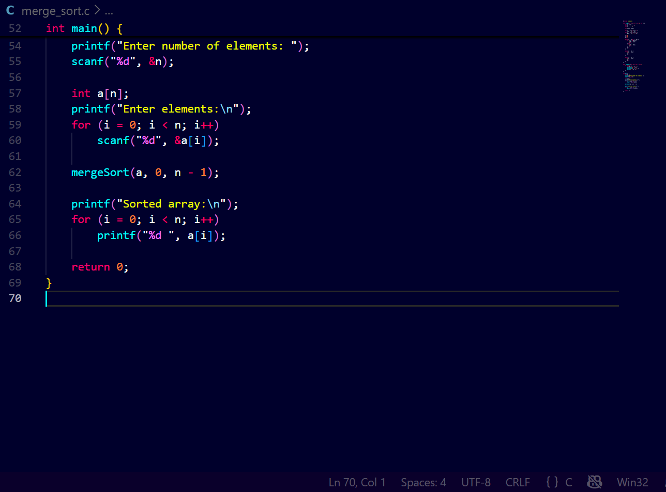
Output
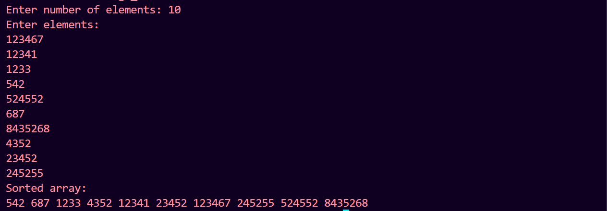

Program 3: Bubble Sort
Aim
To write a C program to sort elements using Bubble Sort technique.
Algorithm
- Read number of elements
- Compare adjacent elements
- Swap if required
- Repeat until sorted
Program Code
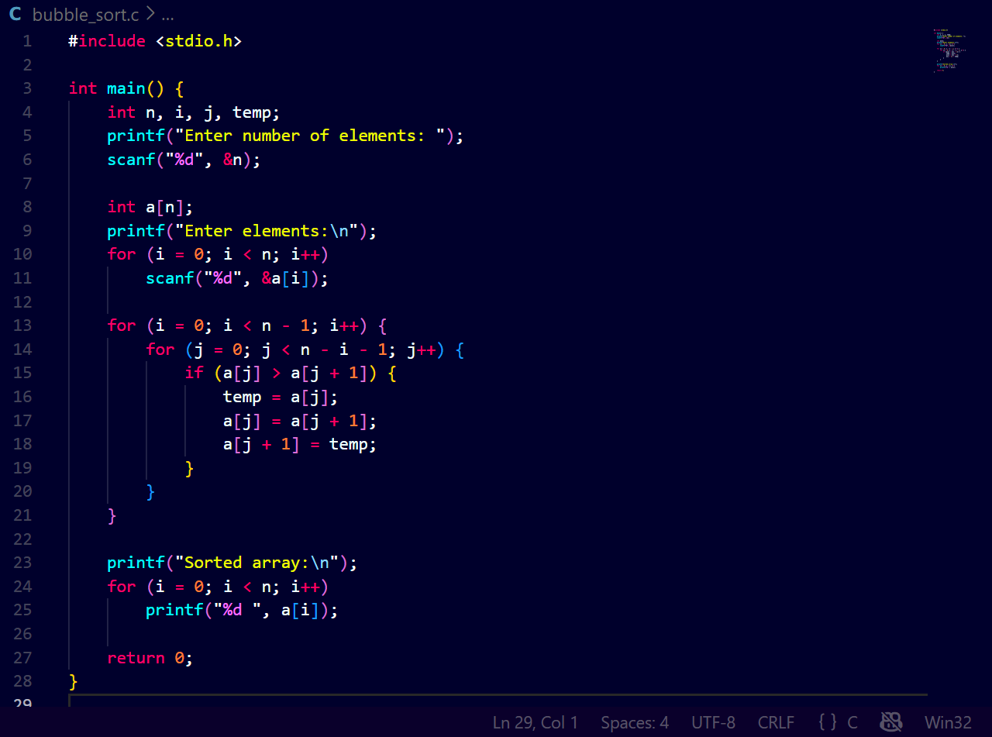Output
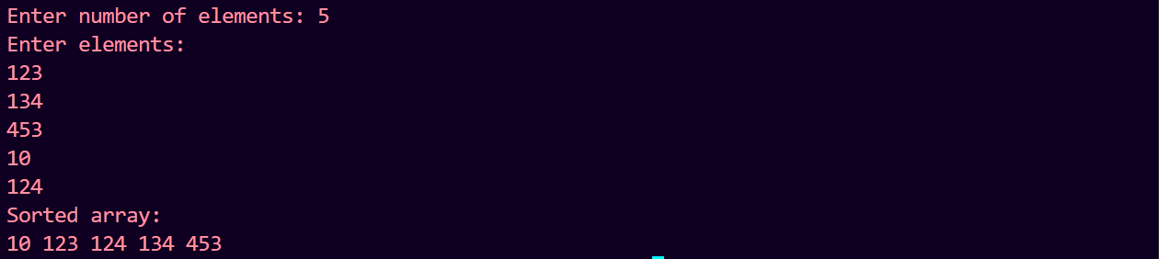
Result
Thus, the given sorting algorithms were successfully implemented and executed.

